# Accelerator for Provider Relationship Management Best Practice Guide

Last updated dated Apr 6, 2022

# 

**Presented by:**

Nikki Pallaras

Catherine Esselman

Leanne Schroeder

Liz Christenbury

Samantha Schultz

Samantha Fried

# 

# Table of Contents

**Accelerator for Provider Relationship Management Best Practice Guide** **0**

**Table of Contents** **1**

**Executive Summary** **2**

**Included Capabilities** **2**

**Process Flow Diagram** **6**

Frequency of Software upgrades and Version Updates 7

**Use Case Scenario** **8**

**Best Practices: Recommendations for Configuration** **9**

Installation Guide 9

Integration 10

Modeling Providers 10

Decision Table and Additional Considerations 10

Previous Modeling of Providers 12

Timeline 12

Providers as Individual Entities 13

Providers and Care Programs 13

Territory Management Usage 13

Security + Data Storage 14

Managing Relationships 14

Assessments Considerations 15

Assessment Feature Matrix 17

**Supporting Documentation** **18**

# Executive Summary

PRM App Accelerator for Health Cloud for Physician Relationship Management (PRM) empowers healthcare organizations of all types to **deliver more personalized and collaborative experiences, efficiently manage provider networks, and grow quality relationships**. PRM provides a comprehensive, scalable solution that meets the broad needs of healthcare organizations business development teams, enabling seamless engagement with providers and/or clinical practice partners based on prioritized service lines. The solution helps eliminate barriers to garnering business to all service lines throughout the healthcare system's geographic service area.

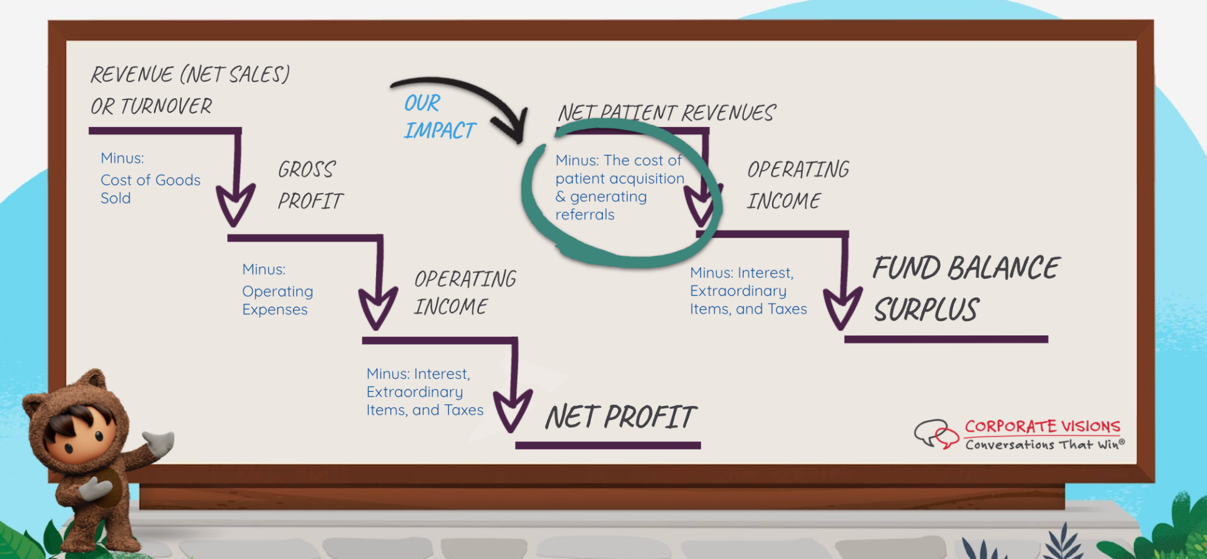

# Included Capabilities

**Provider Relationship Management Data Model**

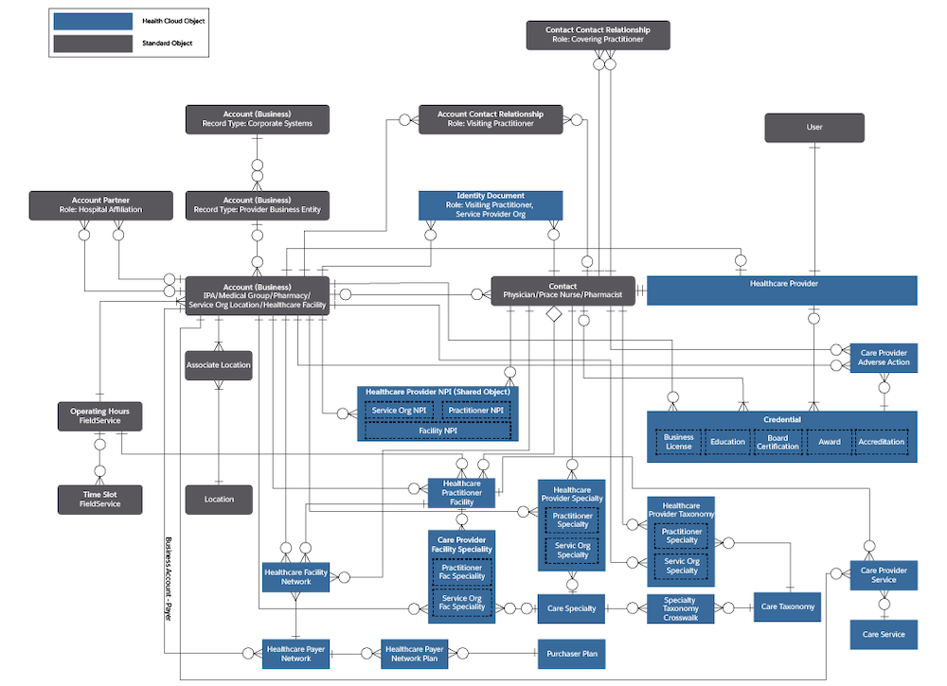

The Health Cloud provider relationship management data model along with standard Salesforce objects manages healthcare system’s network of providers.

* [Provider Relationship Management Overview](https://developer.salesforce.com/docs/atlas.en-us.230.0.health_cloud_object_reference.meta/health_cloud_object_reference/hc_provider_data_model_overview.htm)Use the Health Cloud provider relationship management data model along with standard Salesforce objects to manager your network of providers.
* [Accreditation](https://developer.salesforce.com/docs/atlas.en-us.230.0.health_cloud_object_reference.meta/health_cloud_object_reference/sforce_api_objects_accreditation.htm)Represents the professional accreditations of a facility. For example, a joint commission accredits a facility as a general acute care hospital.
* [Award](https://developer.salesforce.com/docs/atlas.en-us.230.0.health_cloud_object_reference.meta/health_cloud_object_reference/sforce_api_objects_award.htm)Represents a person's or organization's professional awards.
* [BoardCertification](https://developer.salesforce.com/docs/atlas.en-us.230.0.health_cloud_object_reference.meta/health_cloud_object_reference/sforce_api_objects_boardcertification.htm)Represents the practitioner's board certifications such as being board-certified in cardiology and cardiovascular disease.
* [BusinessLicense](https://developer.salesforce.com/docs/atlas.en-us.230.0.health_cloud_object_reference.meta/health_cloud_object_reference/sforce_api_objects_businesslicense.htm)Represents the licenses of a party role like healthcare provider or producer.
* [CareProviderFacilitySpecialty](https://developer.salesforce.com/docs/atlas.en-us.230.0.health_cloud_object_reference.meta/health_cloud_object_reference/sforce_api_objects_careproviderfacilityspecialty.htm)Represents all the specialties that the practitioner provides at a given location. For example, a physician who is board-certified in both spine and neuro may provide spine services at one location and neuro services at another.
* [CareSpecialty](https://developer.salesforce.com/docs/atlas.en-us.230.0.health_cloud_object_reference.meta/health_cloud_object_reference/sforce_api_objects_carespecialty.htm)Represents a listing of provider specialty codes and descriptions. For example, 02 - Physician/General Surgery.
* [CareTaxonomy](https://developer.salesforce.com/docs/atlas.en-us.230.0.health_cloud_object_reference.meta/health_cloud_object_reference/sforce_api_objects_caretaxonomy.htm)Represents a static list of taxonomy codes.
* [HealthcareFacilityNetwork](https://developer.salesforce.com/docs/atlas.en-us.230.0.health_cloud_object_reference.meta/health_cloud_object_reference/sforce_api_objects_healthcarefacilitynetwork.htm)Represents a junction object identifying the insurance network that a location or business entity is a part of.
* [HealthcarePayerNetwork](https://developer.salesforce.com/docs/atlas.en-us.230.0.health_cloud_object_reference.meta/health_cloud_object_reference/sforce_api_objects_healthcarepayernetwork.htm)Represents an insurance network group. For example, an insurance company’s exclusive provider organization (EPO) plans.
* [HealthcarePractitionerFacility](https://developer.salesforce.com/docs/atlas.en-us.230.0.health_cloud_object_reference.meta/health_cloud_object_reference/sforce_api_objects_healthcarepractitionerfacility.htm)Represents the different locations in which a practitioner provides services.
* [HealthcareProvider](https://developer.salesforce.com/docs/atlas.en-us.230.0.health_cloud_object_reference.meta/health_cloud_object_reference/sforce_api_objects_healthcareprovider.htm)Represents business-level details about the healthcare organization or the practitioner.
* [HealthcareProviderNpi](https://developer.salesforce.com/docs/atlas.en-us.230.0.health_cloud_object_reference.meta/health_cloud_object_reference/sforce_api_objects_healthcareprovidernpi.htm)Represents identifiers from the National Provider Identifier that are assigned to every facility and licensed practitioner in the United States. Also includes NPI assigned date, primary mailing address on file, and so on.
* [HealthcareProviderSpecialty](https://developer.salesforce.com/docs/atlas.en-us.230.0.health_cloud_object_reference.meta/health_cloud_object_reference/sforce_api_objects_healthcareproviderspecialty.htm)Represents specialties for a practitioner or a provider service organization. A provider can have multiple specialties such as anesthesiology and cardiovascular.
* [HealthcareProviderTaxonomy](https://developer.salesforce.com/docs/atlas.en-us.230.0.health_cloud_object_reference.meta/health_cloud_object_reference/sforce_api_objects_healthcareprovidertaxonomy.htm)Represents taxonomy or subspecialty codes for a practitioner or facility. A provider or facility can have multiple taxonomies.
* [PersonEducation](https://developer.salesforce.com/docs/atlas.en-us.230.0.health_cloud_object_reference.meta/health_cloud_object_reference/sforce_api_objects_personeducation.htm)Represents information about professional education for a person in a party role.
* [CareProviderAdverseAction](https://developer.salesforce.com/docs/atlas.en-us.230.0.health_cloud_object_reference.meta/health_cloud_object_reference/sforce_api_objects_careprovideradverseaction.htm)This object captures adverse actions against the provider, such as malpractice lawsuits or revoked licences. This object is available in API version 47.0 and later.
* [CareProviderSearchableField](https://developer.salesforce.com/docs/atlas.en-us.230.0.health_cloud_object_reference.meta/health_cloud_object_reference/sforce_api_objects_careprovidersearchablefield.htm)This object holds denormalized data from certain fields in the Provider data model. Provider search APIs query this object instead of multiple objects, which improves search performance. This object is available in API version 47.0 and later.
* [CareProviderSearchConfig](https://developer.salesforce.com/docs/atlas.en-us.230.0.health_cloud_object_reference.meta/health_cloud_object_reference/sforce_api_objects_careprovidersearchconfig.htm)Represents fields that can appear in provider search results. Use this object to specify fields in arbitrary objects (source) that are made available in the search object (target). This object is available in API version 48.0 and later.

The PRM box includes pre-built components leveraging the below products.

**Included Products**

**Health Cloud -** Health Cloud is a patient and provider relationship platform that harnesses cloud, social and mobile technologies to deliver more personalized engagement by providing a complete view of patients and providers and a connected engagement experience. The provider management data model represents the practitioners, facilities, physician relationships, specialties, and organizational hierarchy for the network of providers.

**Shield**

Salesforce Shield is a set of security tools health systems use to comply with regulations on storing sensitive, protected health information. With Platform Encryption and Event Monitoring, health systems can monitor usage, prevent malicious activity, and protect data at rest while leveraging Health Cloud’s full functionality.

**Salesforce Maps**

Salesforce Maps helps healthcare organizations visualize their data, design balanced territories, and plan efficient routes, streamlining administration and reducing drive times. Customers may upgrade to Advanced Maps for planning specific provider visit windows.

## 

# Process Flow Diagram

**Solution Overview and Architecture**

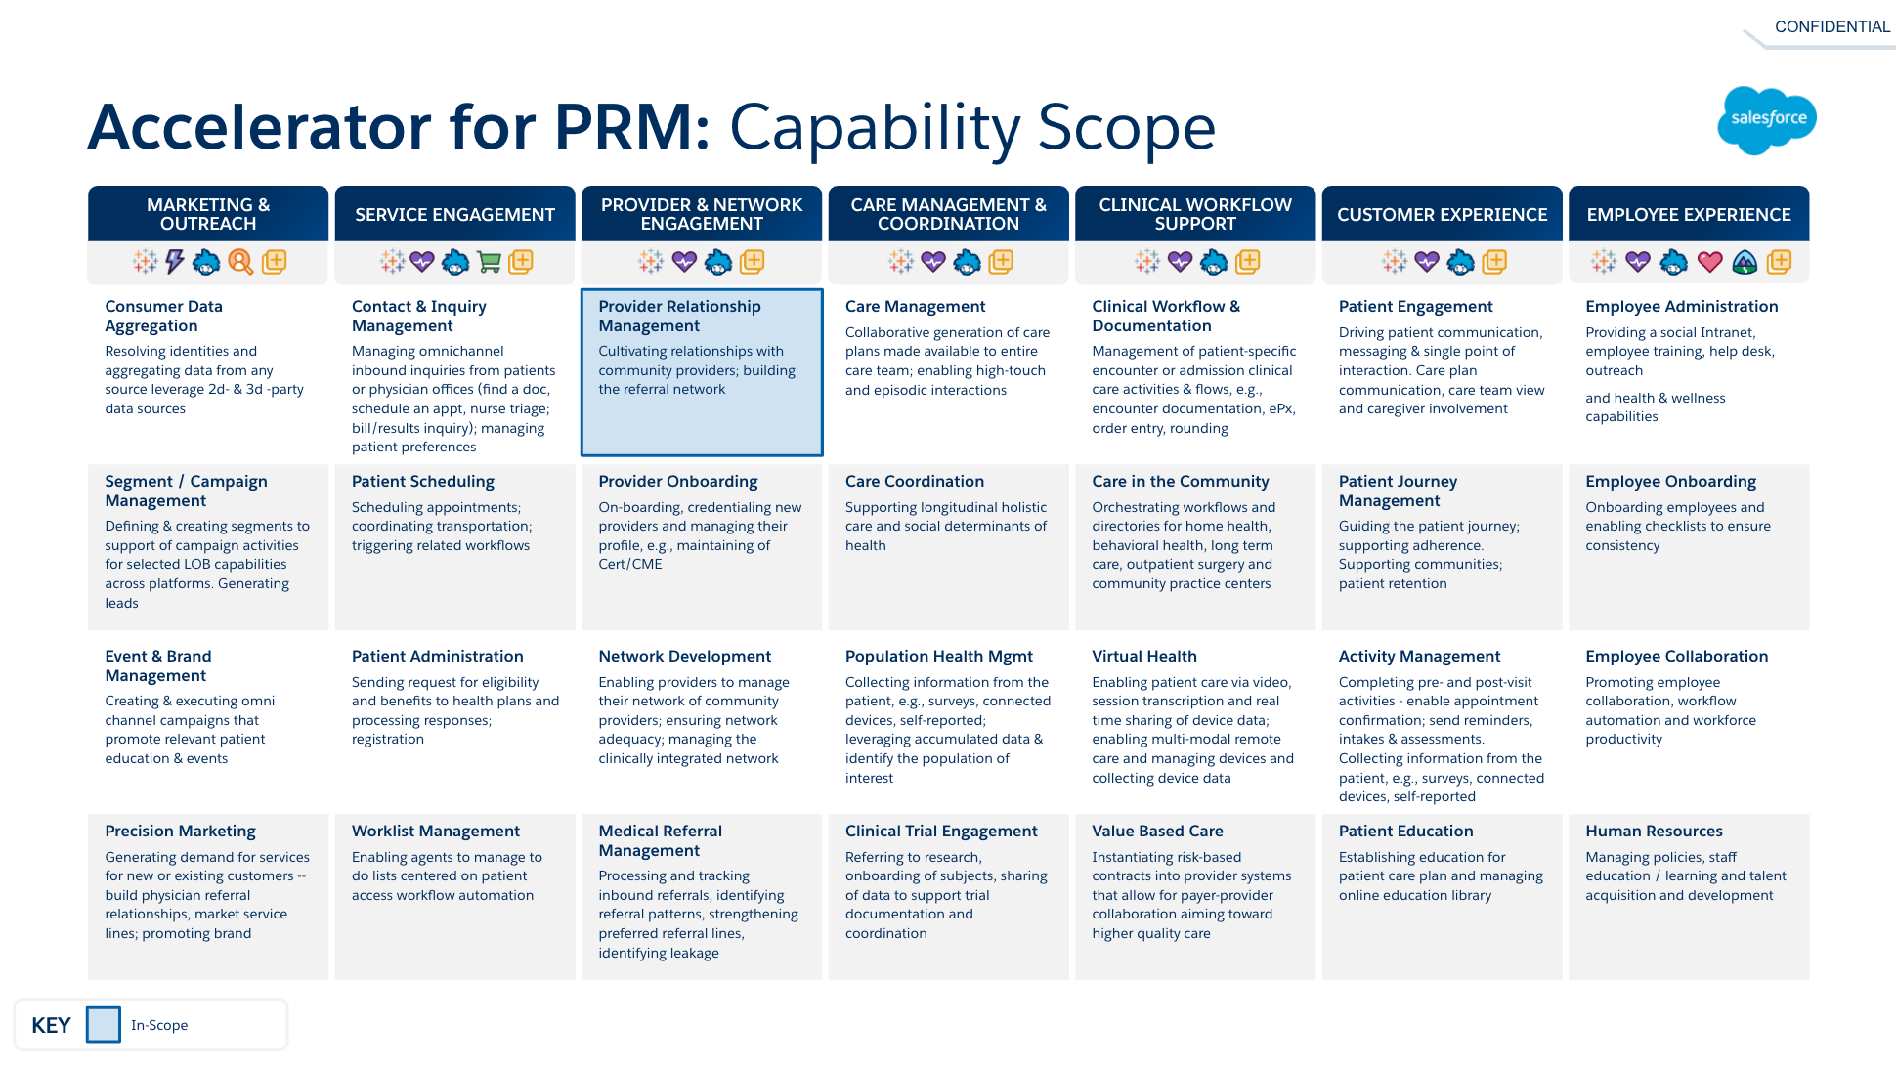

#### Frequency of Software upgrades and Version Updates

At Salesforce, we’re proud to deliver hundreds of innovative features to you three times a year during our seasonal releases: Spring, Summer, and Winter. With our multitenant, metadata-driven platform, we provide customers with seamless, automatic upgrades each release, delivered in real time, with no downtime. It’s all in the cloud, so there’s no worrying about updating hardware or software. Yes, you read that right: upgrades are automatic! That means all customers run the same version of Salesforce, complete with all the latest features.

TRAIL | [Get to know the Salesforce Releases](https://trailhead.salesforce.com/content/learn/modules/sf_releases/sf_releases_start)

**Project Dependencies**

The successful implementation of the PRM solution requires a certified SI implementation approach with close partnership and resource support as necessary from the health system.

Certified SI partners for this approach include:

* Penrod
* Torrent
* Coastal Cloud
* CopperHill

**Solution Assumptions**

The solution we recommend assumes the following:

1. Every customer is responsible for configuring this solution in line with specific organizational policies and procedures. This includes content within email templates, parameters for assigning tasks and territories, custom fields, etc.

Use Health Cloud objects for the provider data model.

Outside of the delivered Process Builder, Flow should be used for appropriate automation functionality.

Configure Provider Relationship Cards to visualize complex provider relationships on one page. You can use the Lightning App Builder to add the relationship card component to an Account or Contact page and specify the relationship card types to be included on that page. You can see all the objects—provider organizations, hospital locations, operating hours—and the different attributes—specialty, creds, NPIs—that are related to that account or contact. For example, on the Contact page, you can see all the accounts with which that contact has a relationship. In the case of a health care practitioner, you can see all the hospital locations with which the practitioner is affiliated. Learn more about Relationship Cards [here](https://trailhead.salesforce.com/en/content/learn/modules/health-cloud-provider-relationships-search/configure-provider-relationship-cards).

# Use Case Scenario

The solution follows the Business Development Representative/Liaison and manager roles in a healthcare system. The solution personalizes the experiences for the Liaison and the providers they are communicating with, and connects providers to the right information about the health system faster.

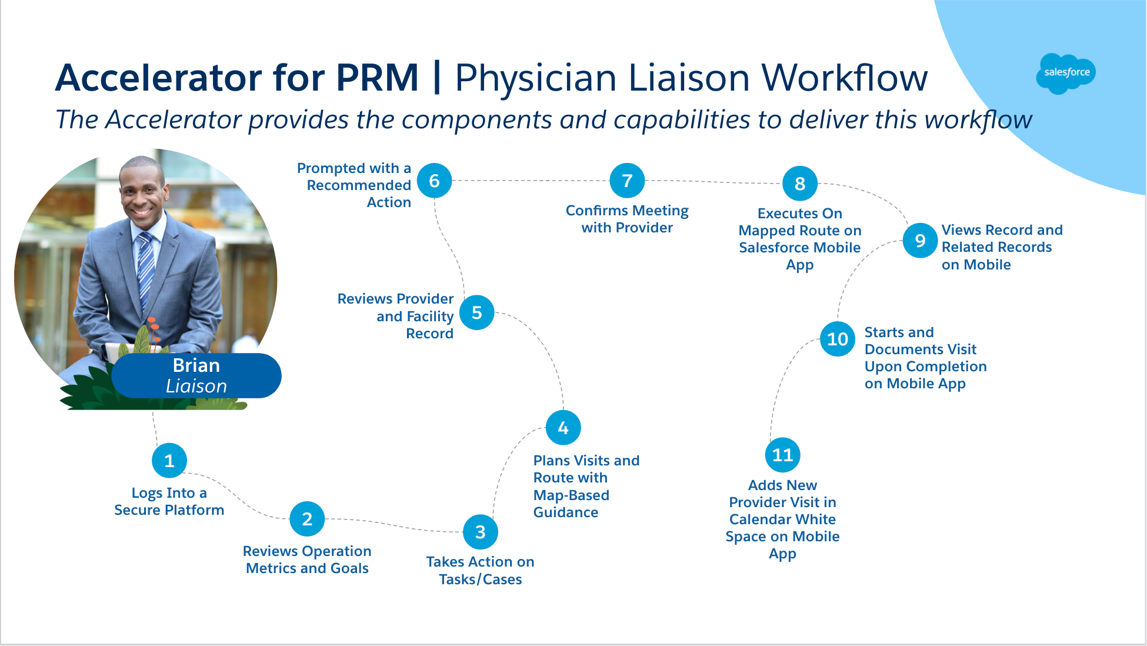

# Best Practices: Recommendations for Configuration

#### Installation Guide

[**PRM App Accelerator for Health Cloud - Component Package Installation Guide**](https://docs.google.com/document/d/1_NWoeJFZNqKmq6IrOPgLKANTKXOnpk6xF5770Llx_XI/edit#heading=h.tpshq9ys5868)[**1**](https://docs.google.com/document/d/1_NWoeJFZNqKmq6IrOPgLKANTKXOnpk6xF5770Llx_XI/edit#heading=h.tpshq9ys5868)

[Pre-Installation Steps:](https://docs.google.com/document/d/1_NWoeJFZNqKmq6IrOPgLKANTKXOnpk6xF5770Llx_XI/edit#heading=h.t96unt60g0bn) [2](https://docs.google.com/document/d/1_NWoeJFZNqKmq6IrOPgLKANTKXOnpk6xF5770Llx_XI/edit#heading=h.t96unt60g0bn)

[Installation Steps:](https://docs.google.com/document/d/1_NWoeJFZNqKmq6IrOPgLKANTKXOnpk6xF5770Llx_XI/edit#heading=h.ot794ite4v8l) [2](https://docs.google.com/document/d/1_NWoeJFZNqKmq6IrOPgLKANTKXOnpk6xF5770Llx_XI/edit#heading=h.ot794ite4v8l)

[Post-Installation Steps:](https://docs.google.com/document/d/1_NWoeJFZNqKmq6IrOPgLKANTKXOnpk6xF5770Llx_XI/edit#heading=h.l287isqezljb) [3](https://docs.google.com/document/d/1_NWoeJFZNqKmq6IrOPgLKANTKXOnpk6xF5770Llx_XI/edit#heading=h.l287isqezljb)

[Unmanaged Package Component Inventory](https://docs.google.com/document/d/1_NWoeJFZNqKmq6IrOPgLKANTKXOnpk6xF5770Llx_XI/edit#heading=h.cp04meiiosu7) [7](https://docs.google.com/document/d/1_NWoeJFZNqKmq6IrOPgLKANTKXOnpk6xF5770Llx_XI/edit#heading=h.cp04meiiosu7)

#### Integration

Salesforce recommends leveraging scheduled automatic batch loads via SFTP weekly for provider data pulls.

Salesforce Technical Architect (TA) assessments are available for healthcare organizations interested in real-time integrations to explore options such as Mulesoft, Redox, Elkay, CopperHill, or an/AppX Partner.

#### Modeling Providers

When modeling different personas within Health Cloud, there are a lot of options available, but also best practices you should follow based on what healthcare organizations goals. Modeling practitioners, or providers, is no exception.

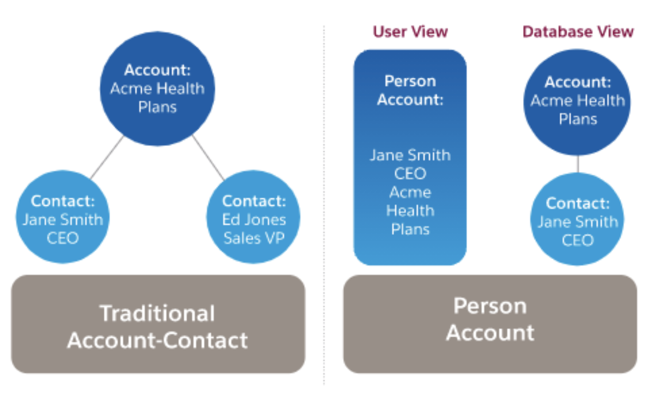

#### Decision Table and Additional Considerations

How to interpret the following table:

Salesforce offers multiple ways to model providers so it’s important to understand the near-term and long-term needs of the organization to make the best choice for modeling providers. The questions below offer a guide to this decision making. Once you’ve completed answering the questions for your implementation, add which column represents more answers that align with your implementation. The column your answer appears in indicates the better choice for modeling providers, and ideally all of your answers are in the same column. For example, a New Org that will not have External Apps Licenses (Partner Licenses) for providers would typically use Person Accounts for providers, whereas an existing org that already has modeled providers as Contacts and will use External Apps Licenses for those providers would typically model providers as Contacts. A “Yes” in both columns indicate that the functionality is supported by both Contacts and Person Accounts and is usually not a factor in the decision.

| **Question** | **Contacts** | **Person Accounts** |
| --- | --- | --- |
| Is this a net new implementation? (New Org) | No | Yes |
| Do you currently have providers modeled in your system as Contacts? | Yes | Yes |
| Are you using, or planning, to use Experience Cloud with Partner Licenses or External Apps Licenses? | Yes | No |
| Do you need to leverage Timeline for Physicians? | No | Yes |
| Do you need to connect to Marketing Cloud? | Yes | Yes |
| Do you need to leverage Life Events for Physicians? | Yes | Yes |
| Do you treat providers as independent entities? | No | Yes |
| Do you need to associate Providers with Care Programs? | Yes | Yes |
| Do you need to manage Territory Management via Providers, rather than at a facility level? | No | Yes |
| Do you need to leverage the OOTB "Create Provider" API with Health Cloud? | Yes | Yes |
| Do you plan on using PNM's Network Participation flow / component? | Yes | Yes |
| Are you planning on using Intelligent Appointment Management? | Yes | Yes |
| Are you fully mapping to the 'Practitioner' FHIR resource? | Yes | [Yes](https://developer.salesforce.com/docs/atlas.en-us.health_cloud_object_reference.meta/health_cloud_object_reference/map_fhir_practitioner.htm) |
| Do you need to leverage delegated access within Experience Cloud? | Yes | No |

#### Previous Modeling of Providers

* In the past, providers were only recommended to be modeled as Contacts. With that, a number of legacy orgs have providers modeled that way. If a customer is apprehensive to the change, be aware of some of the features they may not have access to if they model as Contacts.
* You can migrate providers from Contacts to Person Accounts but the work involved can be significant, depending on the code and configuration involving Accounts and Contacts. All will need to be evaluated for potential changes to accommodate the new Person Account Record Type and data will need to be exported and reimported.

#### Timeline

* While this component is generally used for Patient Management, it can also be leveraged to chronologically display events for a Provider, if modeled as Person Accounts.
  + If the provider is a Contact, then the timeline on the provider contact page will lookup to the business account and will display all events related to the business account (such as the Hospital or clinic). Any events related to the Contact won’t work.
* The Timeline component works on an object page which is related to an Account and displays the timeline events associated to that account.
* Setup unique Timeline View Configurations for the Provider (compared to the Patient) making sure you’re looking up to the Account side of the Provider relationship for the data you want to show.

#### Providers as Individual Entities

* Many times, Providers are looked at as individual, independent entities, who have practicing rights at a number of locations. They have their own unique identification number, such as a NPI, which follows them regardless of where they work. They also may not have a primary location, the way traditional Business Accounts and Contacts are modeled.
* This reasoning alone would drive a company towards a Person Account model if no other considerations are being looked at.

#### Providers and Care Programs

* The Care Program functionality has a supporting object called ‘Care Program Provider’. This object is also referenced in the out of the box guided flow template (Program Enrollment Flow) from Health Cloud.
  + The Care Program Provider object has two options to build a relationship with a provider. You can leverage the AccountID field (Account Lookup) OR the CareProgramContactId (Contact Lookup) to appropriately make the relationship.

#### Territory Management Usage

* The platform-level Territory Management functionality is Account-driven. If you need to manage territories at the provider level, instead of at the traditional facility (or Account) level, you will need to model providers as Person Accounts. Territory Management does not support Contacts.
* Territory requirements need to be heavily analyzed as often Providers are commonly at different locations during the week. Because of this, it may be useful to leverage the facilities (Accounts) in territories to line up with rep visits/virtual calls, and therefore Providers at the facility on a given day and the associated Leads/Opps for those Accounts.
* Advanced Maps has capabilities for Visit Windows which can be helpful with route planning for those Providers.
  + Maps Advanced would help with the scenario where a Provider is related to multiple accounts and to plan a route you need to know there is a visit window Mondays & Wednesdays from 1-5 at Account #1 (and therefore the rep won't be sent to that location on Tuesdays and Thursdays when the Provider works at a different location).
  + If Visit Windows aren't needed, standard Maps can be used.

#### Security + Data Storage

* If person accounts are enabled, the organization-wide default sharing must be set in one of the following ways:
  + Contacts are set to Controlled by Parent,
  + or accounts and contacts are both set to Private.
* Data storage is higher with Person Accounts as there is both an underlying Contact and Account record.

#### Managing Relationships

* Healthcare Practitioner Facility
  + Regardless of how providers are modeled, leverage this object to manage relationships between providers and the facilities or clinics they work at
  + Using this object is important for a number of downstream features, such as Provider Search and Intelligent Appointment Scheduling
* Account to Contact
  + Leverage this object to manage relationships between non-clinical staff and non-primary facilities or clinics that support
    - Non-Primary due to the fact that non-clinical staff are modeled as Contacts and will have a standard Business Account to Contact relationship for primary relationships
  + Regardless of how providers are modeled, leverage this object to track non-working affiliations for providers, such as being members of the American Medical Association or American Academy of Family Physicians
* Contact to Contact
  + When Providers are modeled as Person Accounts or Contacts, leverage this object to manage relationships between providers and non-clinical staff
    - Note for this setup - You have to edit the Contact-Contact Relationship Page Layout to add all relevant fields. You also should create a tab for Reciprocal Roles and their respective inverse relationship to be able to associate the roles (ex. Mentor/Mentee)
  + When Providers are modeled as Person Accounts or Contacts, leverage this relationship to manage provider to provider relationships (ex. mentor / mentee)
* Account to Account
  + Leverage this object to track business account to business account relationships, such as affiliations
    - Note that there are specific objects for functionality, like Purchaser Group, available with Health Cloud
* Person Accounts can be related to Accounts and Contacts but that said, Parent Account, Reports to and View Hierarchy fields are not available.

#### Assessments Considerations

Health Cloud includes unlimited survey responses and assessment functionality leveraging Salesforce Surveys. There are additional ways to capture assessments within Health Cloud as well.

| **Option** | **Advantages** | **Considerations** |
| --- | --- | --- |
| **Salesforce Surveys (Assessments)** | - Pre-built to allow for scale in the number of surveys  - Versioning of Surveys / Question Response Data Model  - Can gather via Authenticated or Unauthenticated Site  - Ability for simple branching at a section and question level  - Ability to integrate with WhatsApp  - Supports 10 question types  - Supports Merge Fields (Additional License Type)  - Supports Versioning  - Auto-Send on triggers / events in with Invitation Rules or Process Builder  - Ability to Pause and resume  - Branding Customizations  - Built-in analytics on survey responses  - Unlimited responses included with Health Cloud licenses  - Ability to export responses to CSV easily  - Ability to send via WhatsApp (Winter ’21) | - Limited reporting model  - Experience Cloud Site Setup Required  - No offline mobile format  - Inability to invert scales on responses  - Unauthenticated surveys require customization to associate -with the submitter (workaround)  - No OOTB scoring / risk analysis  - No access to "Question Bank"  - No ability to embed interactive images (ex. image of body to -select area of pain)  - Can only complete each survey one time. A new invitation -must be sent using the Survey Invitation API if you want users to take a survey multiple times (ex: wellness attestation) |
| Screen Flows + Parsing Out Data | - Flexibility in branching and decisions  - Flexibility in UI / can incorporate LWC  - Respective answers available in FHIR-standard objects related to the patient  - Ability to leverage SubFlows  - No additional cost  - Ability to expose in Experience Cloud | - Need custom object or something to junction the initial assessment - content is coming from  - No offline mobile format  - Flows were not created for complex assessments with a lot of questions  - Limited for complex / dynamic forms  - Scale issues potentially |
| Screen Flows + Clinical Assessment Response Object | - Flexibility in branching and decisions  - Flexibility in UI / can incorporate LWC  - Leverage existing HC object for responses  - Ability to leverage SubFlows  - No additional cost  - Ability to expose in Experience Cloud | - Limitations on 500 custom fields per object  - No offline mobile format  - Flows were not created for complex assessments with a lot of questions  - Limited for complex / dynamic forms  - Scale issues potentially |
| OmniScript | - Flexibility in branching and decisions  - Ability to run in a LWC container  - Ability to expose in Experience Cloud  - UI-first designer; higher flexibility in screen design (near pixel perfect) | - No offline mobile format  - Add-on SKU required  - DPA SKU is not HIPAA compliant  - HINS/PNM SKU is HIPAA compliant  - Need to data model to support responses (see flow object solutions above for options)  - Doesn't leverage Health Cloud Data model natively  - Unable to deploy leveraging Change Sets |

There are two Feedback Management add-ons for surveys which provide additional functionality. Learn more about those [here](https://help.salesforce.com/s/articleView?id=sf.concept_add_on_license.htm&type=5).

#### Assessment Feature Matrix

| **Option** | **Salesforce Surveys** | **Flows** | **OmniScript** |
| --- | --- | --- | --- |
| Included with Health Cloud? | Yes | Yes | Add-On |
| Complex Branching/Logic (by section) | No | Yes | Yes |
| Basic Branching/Logic (by question) | Yes | Yes | Yes |
| Offline? | No | No | No |
| Mobile Support? | Yes | Limited | Yes |
| Experience Cloud Support? | Yes | Yes | Yes |
| Syncs to Custom Objects? | No | Yes | Yes |
| Works with Person Accounts? | Yes |  | Yes |
| Pause and Resume? *(save)* | Yes *(authenticated surveys only)* | Yes |  |
| Pre-Populate Data from Patient | Yes  *(basic merge field)* |  |  |
| Pre-Populate Data from Previous Assessments | No |  |  |
| Reporting | Yes |  |  |
| Question Library | No |  |  |
| Calculate Scoring | No | Yes |  |
| HIPAA Compliance | via Shield Encryption | via Shield Encryption | via DPA - No  via HINS - Yes |

# Supporting Documentation

| **Asset** | **Description** |
| --- | --- |
| [Health Cloud Release Notes](https://help.salesforce.com/articleView?id=release-notes.salesforce_release_notes.htm) | Dive deeper into the latest Health Cloud release and learn how customers can access the new features. |
| [Setting up Health Cloud](https://developer.salesforce.com/docs/atlas.en-us.health_cloud.meta/health_cloud/admin_planning.htm) | Learn how to install the managed package |
| [Health Cloud Data Model](https://developer.salesforce.com/docs/atlas.en-us.health_cloud.meta/health_cloud/admin_data_model.htm) | More information on Health Cloud's data model in Salesforce Developers |
| [Health Cloud Objects](https://developer.salesforce.com/docs/atlas.en-us.health_cloud_object_reference.meta/health_cloud_object_reference/sforce_api_objects.htm) | Learn about the rich set of standard and custom objects to store and access specialized health information. |
| [FHIR R4 FAQ](https://salesforce.quip.com/QOIPAbuuGHM7) | Learn about R4, aka Release 4, of HL7 FHIR (Fast Healthcare Interoperability Resources) through FAQs, customer questions, demo resources, etc. |
| [Salesforce Health Cloud Datasheet](https://c1.sfdcstatic.com/content/dam/web/en_us/www/assets/pdf/datasheets/healthcloud-datasheet.pdf) | Datasheet for Health Cloud for Providers |

